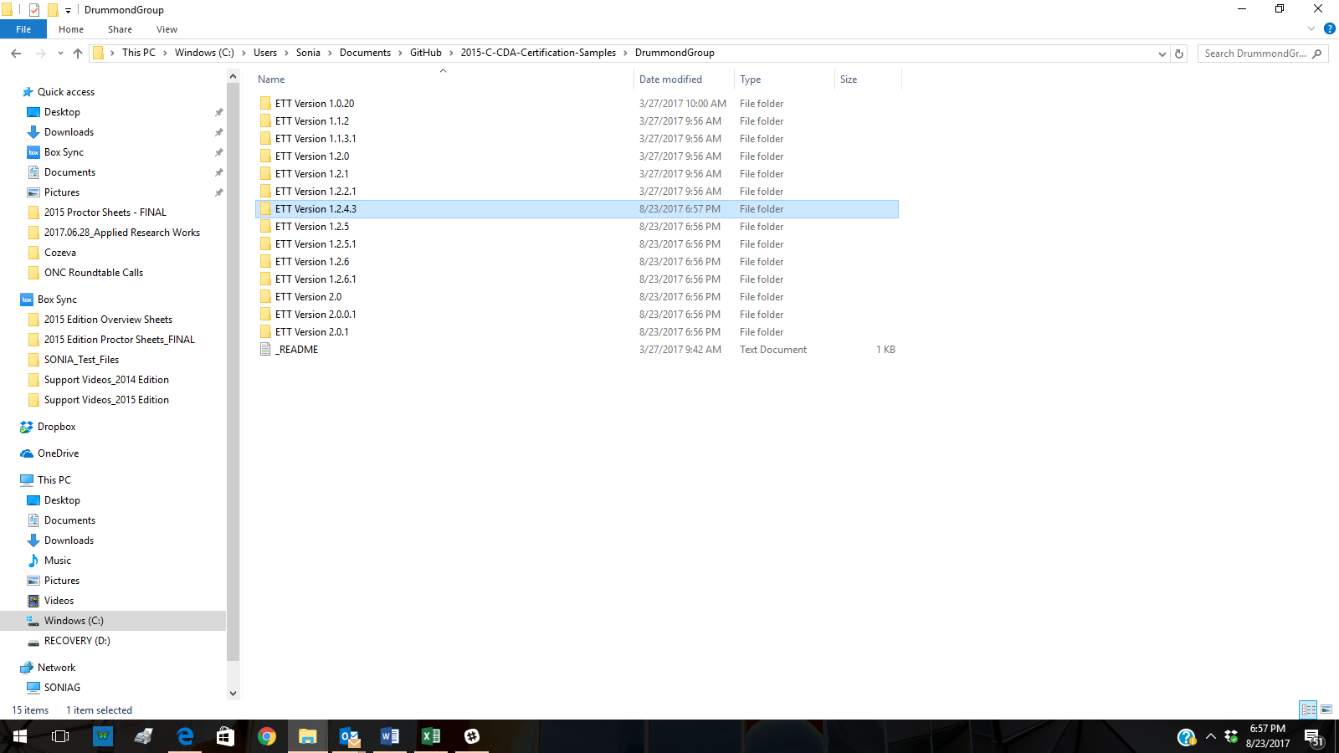

In your local Github directory, add in any folders or files you wish to upload to the ONC Repository

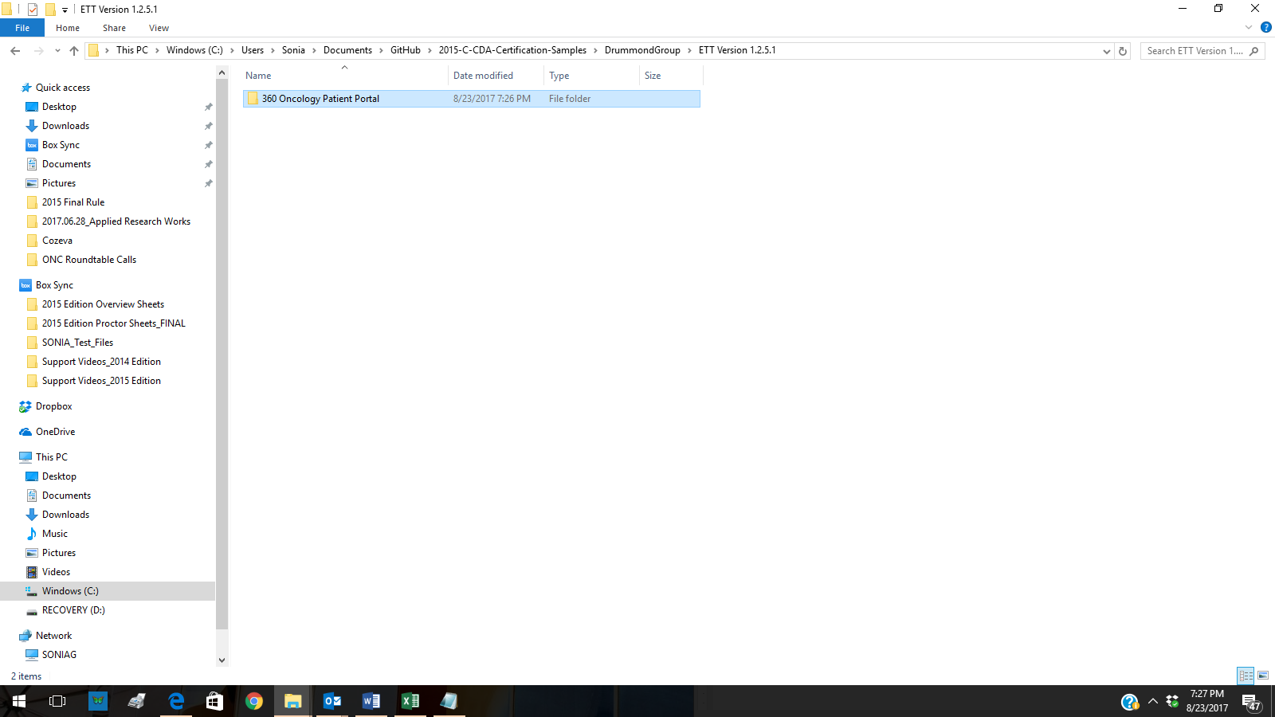

Adding folder based on “Vendor Name” and adding CCDA contents for each criteria

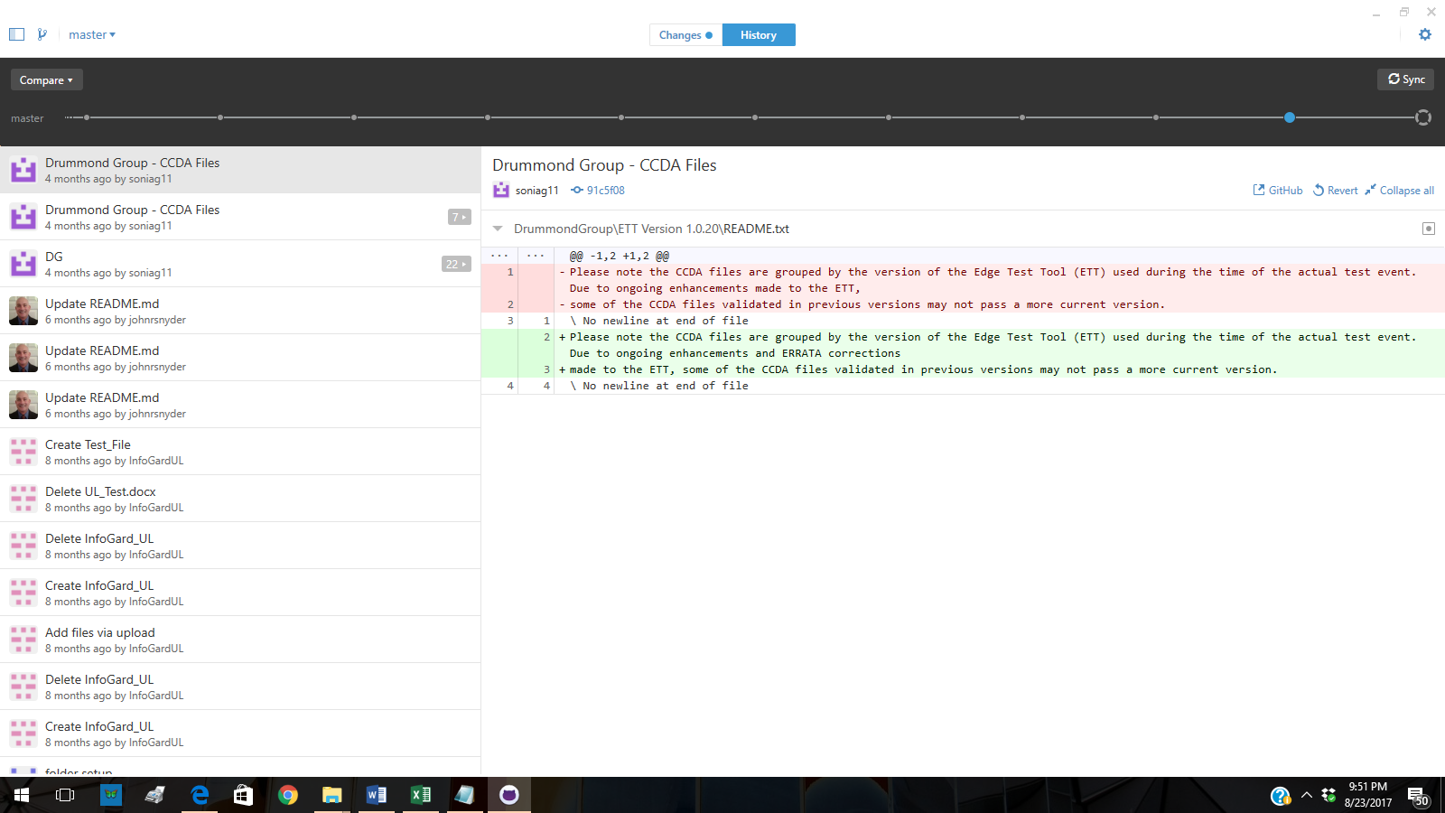

Landing page when you open Github Client. From here, click the “Changes” tab at top center

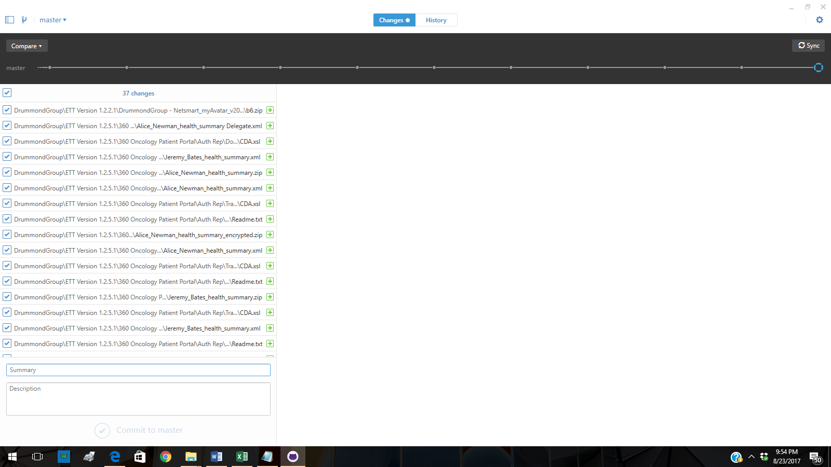

On CHANGES tab, you will see all of the files you just added to your local Github directory

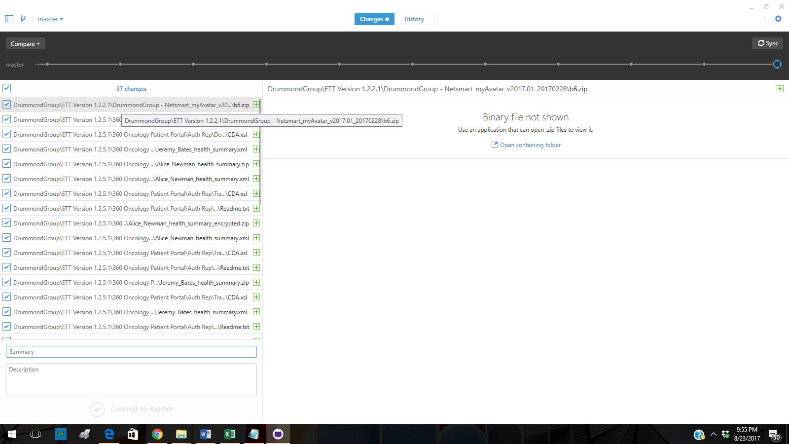

Click on first file at the top.

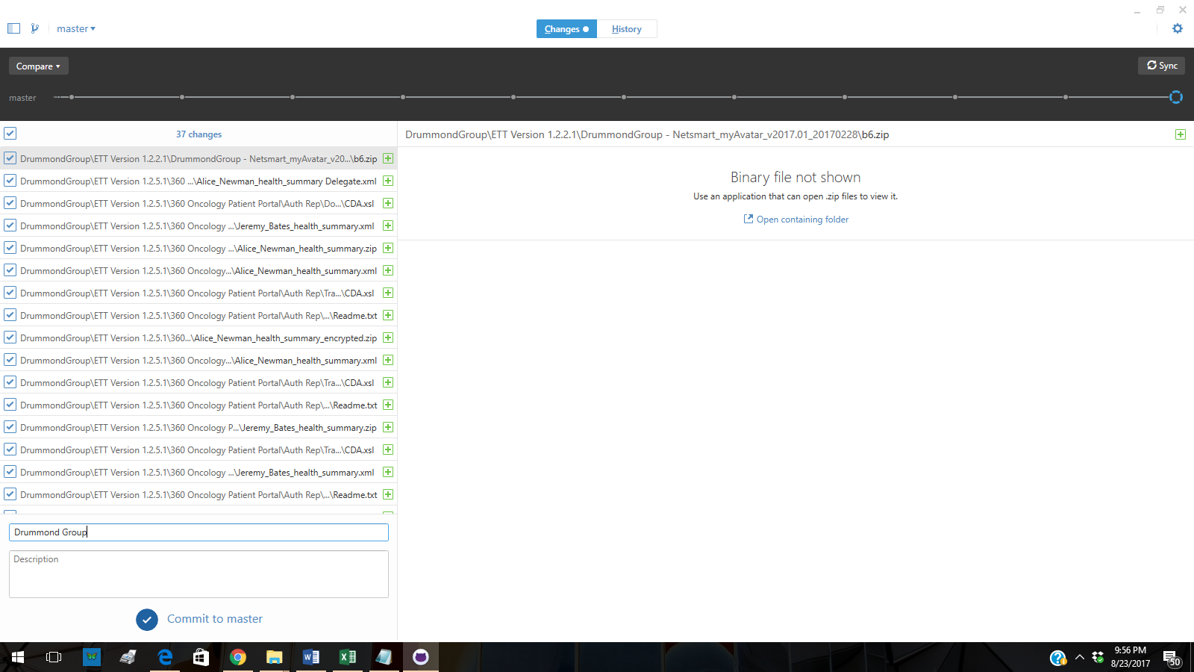

At the bottom left enter a summary such as “Drummond Group” then click “Commit to Master”

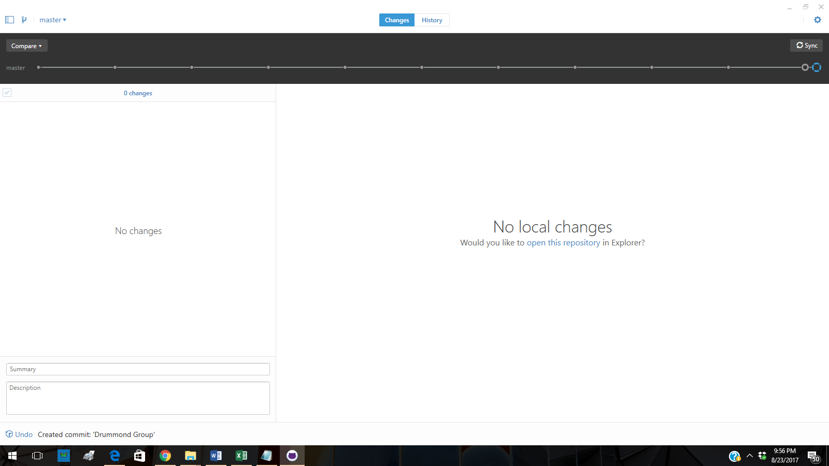

Next you click “Sync” at top right of page

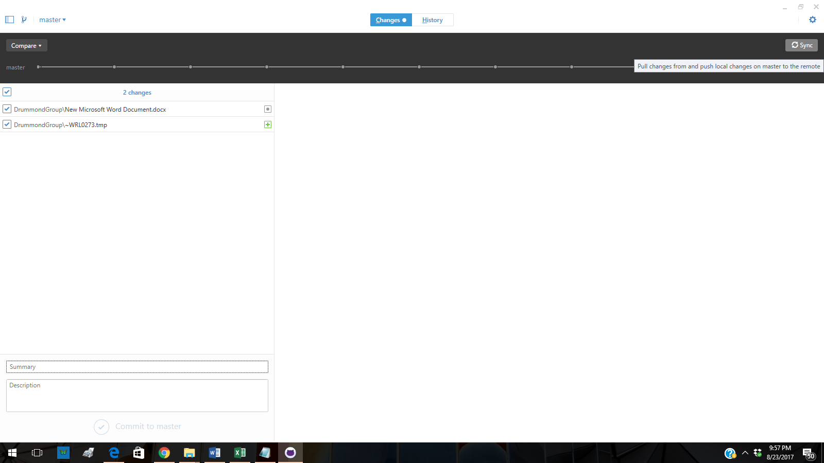

Click SYNC

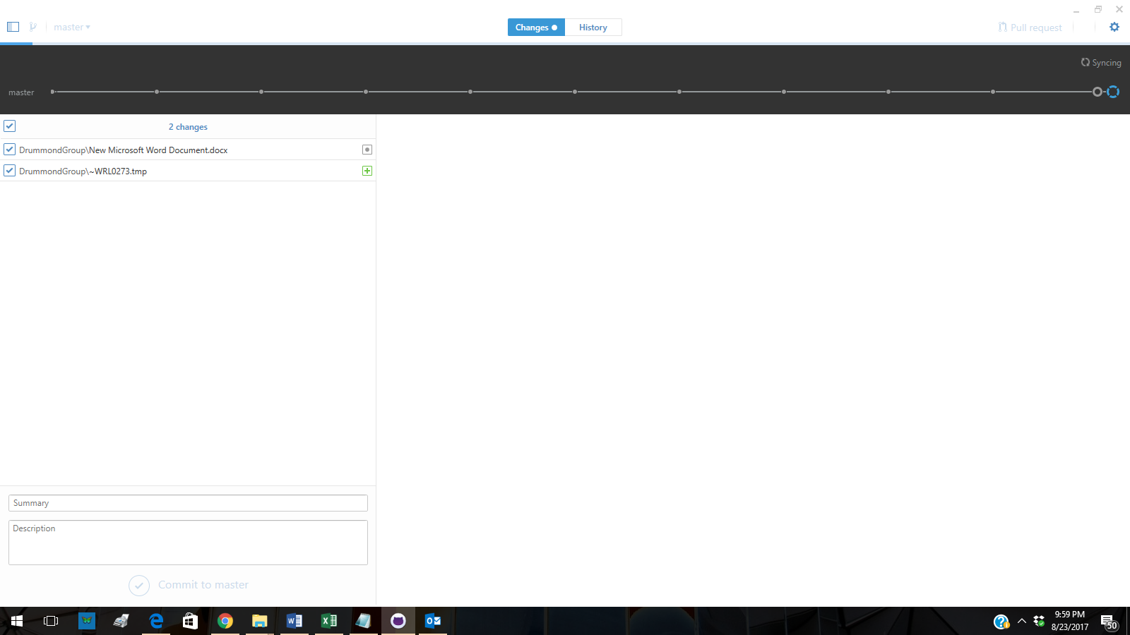

Files sync’ing (see top right)

Once un-synched or sync is finished, files will appear in Github

Changes now committed and uploaded to ONC Repository